NAME: VIJAY VARSITH I REG NO: 241901125

Experiment 16: : Footprint a Wireless Network

Aim :
- To perform wireless network footprinting — identifying nearby networks, their SSIDs, channels, encryption type, and connected clients — using Kali Linux tools, in a simulated/offline lab setting.

Tools Required :
- Kali Linux
- Wireshark
- Aircrack-ng suite (airodump-ng, used here to read a saved capture file instead of live capture)
- A sample .pcap wireless capture file (Aircrack-ng ships sample test captures, or your instructor will provide one)

Procedure :
- Step 1 — Open the capture file in Wireshark
- wireshark sample_capture.pcap
- Step 2 — Filter for beacon frames (this reveals every advertised network)
- In the Wireshark filter bar:
- wlan.fc.type_subtype == 0x08
- Each result is one Access Point announcing itself. Expand a packet to see the SSID, channel, and supported rates.
- Step 3 — Identify encryption type
- Look inside the "Tagged Parameters" section of the beacon frame for RSN Information (WPA2) or the absence of it (Open network) or WEP Parameters.
- Step 4 — Identify connected clients
- Filter for data frames to see device (client) MAC addresses talking to a specific AP:
- wlan.addr == <BSSID-of-target-AP>
- Step 5 — Analyze the same file with airodump-ng (offline read mode)
- airodump-ng --read sample_capture.pcap
- This produces the classic table view: BSSID, PWR, channel, encryption (WEP/WPA/WPA2), ESSID, and associated client stations.

Expected Output :

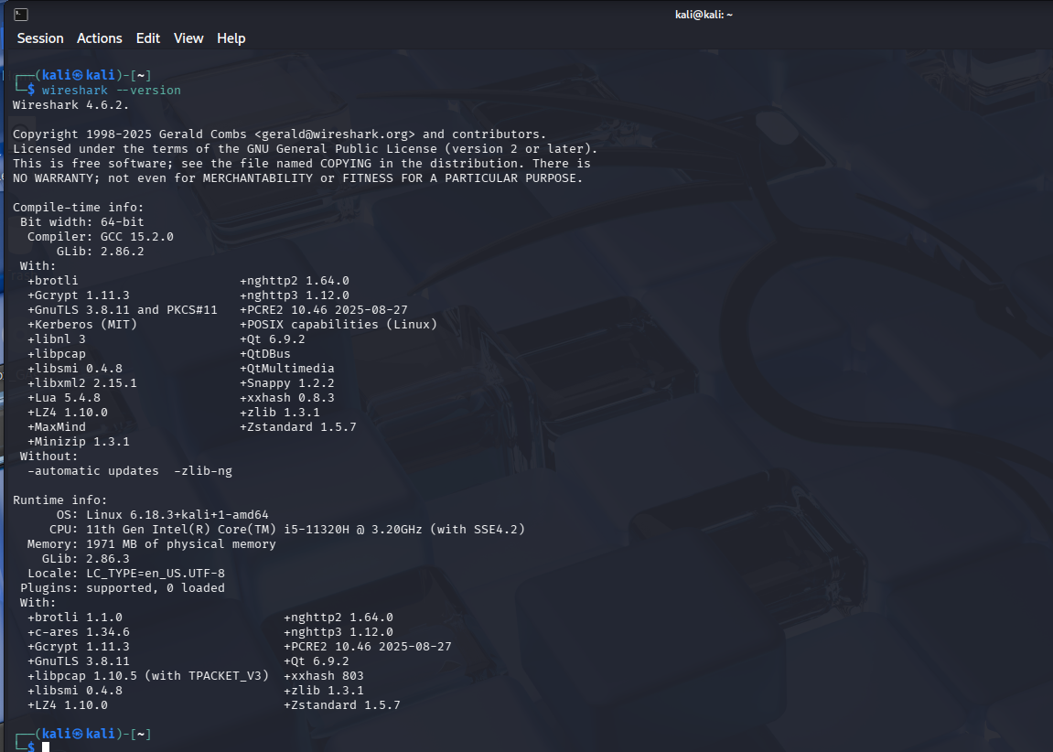

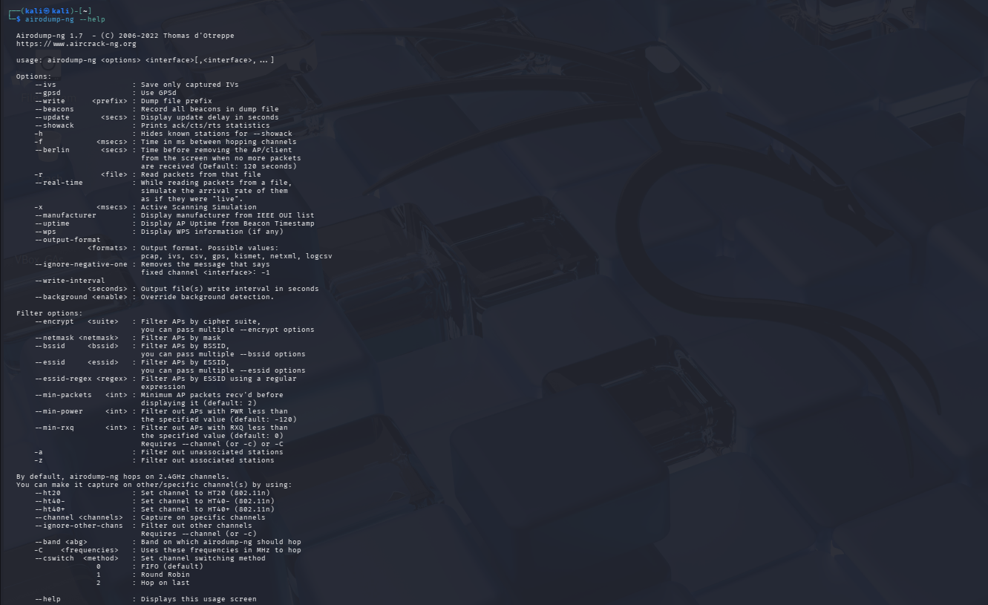

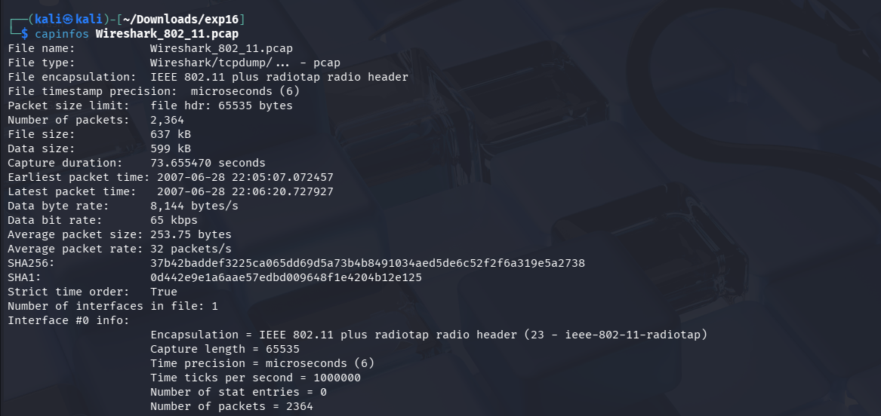

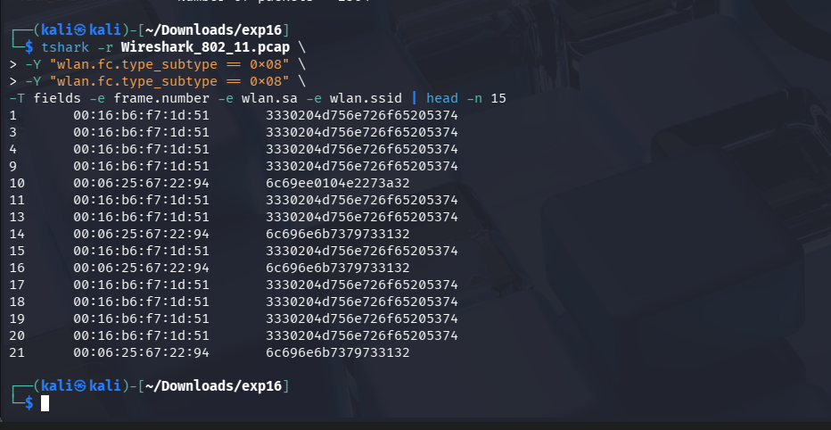

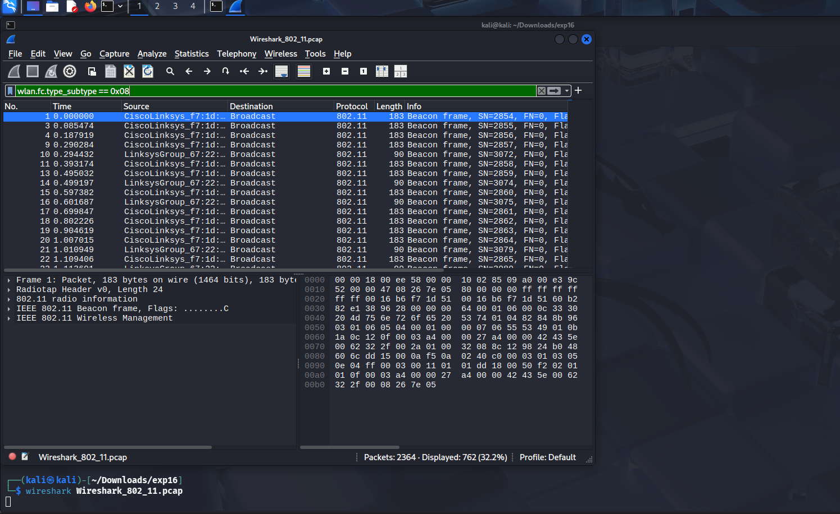

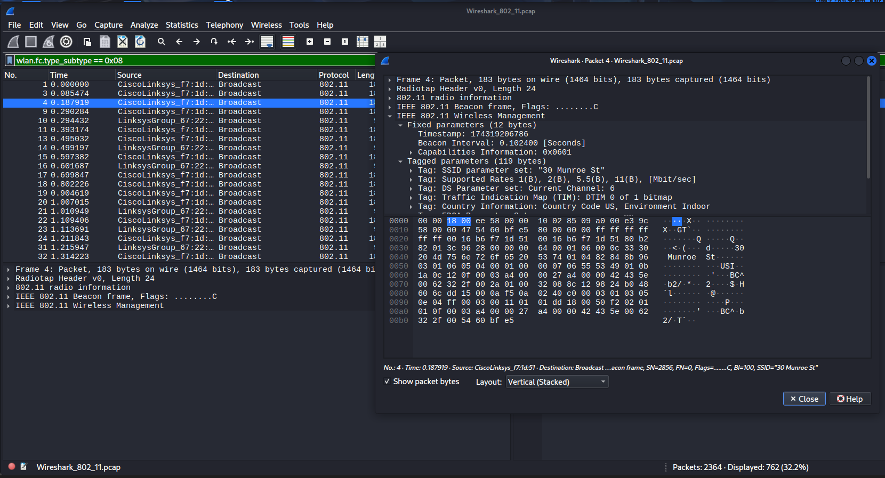

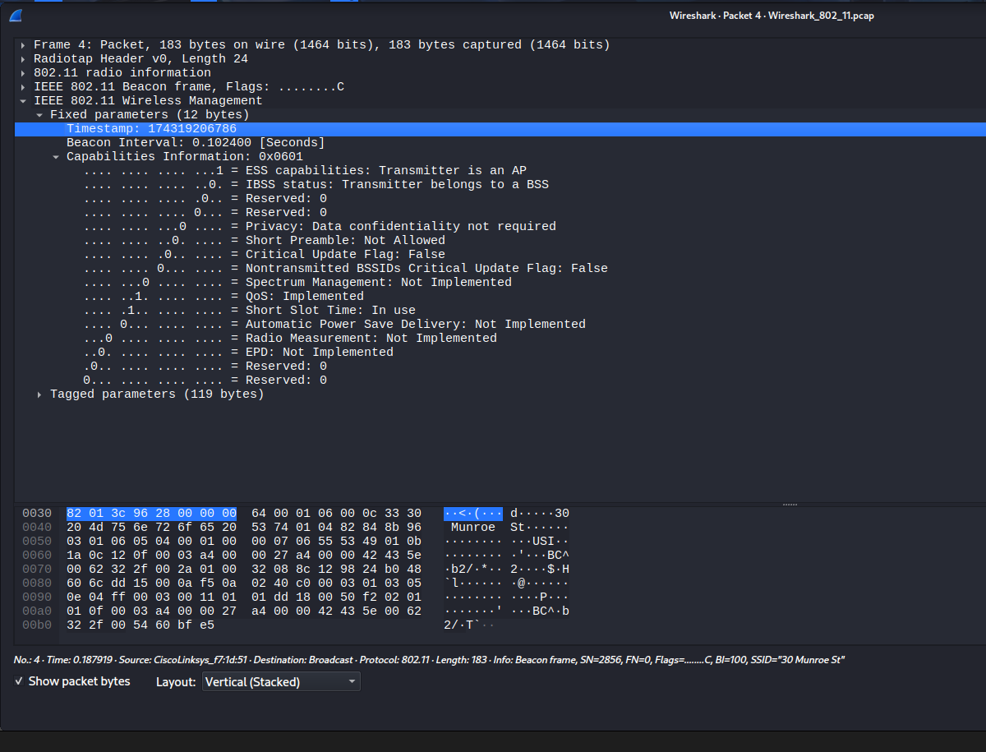

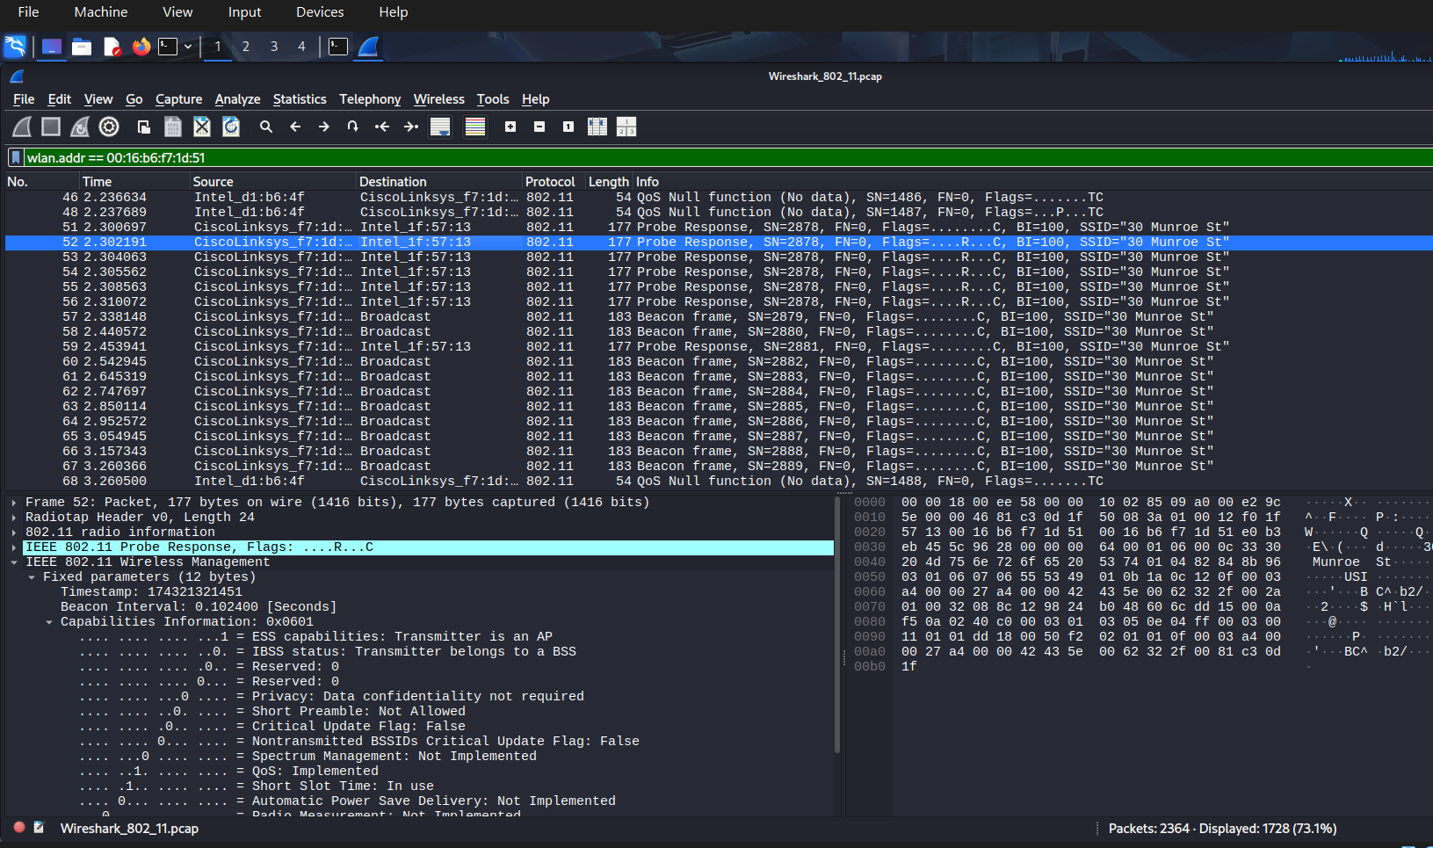

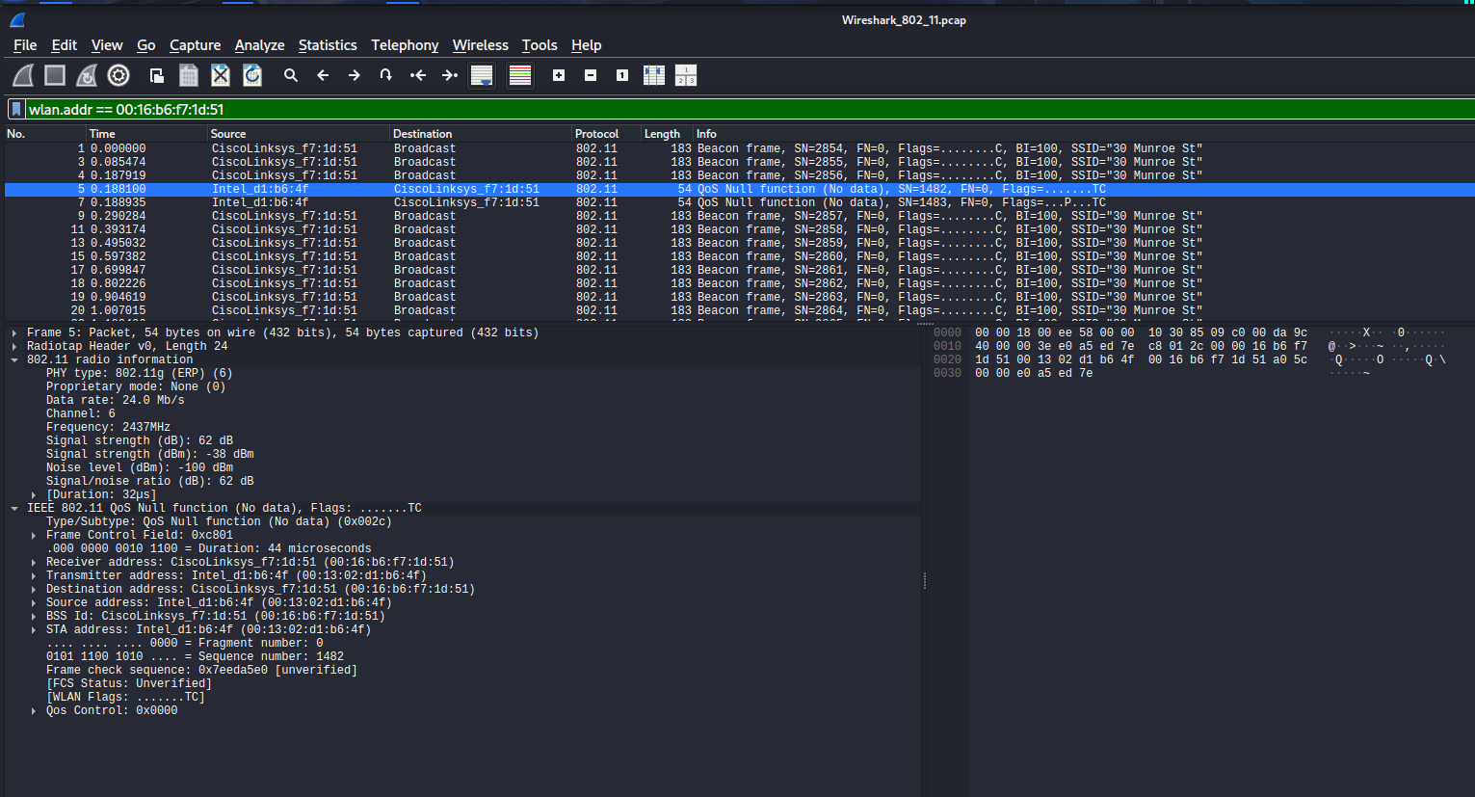

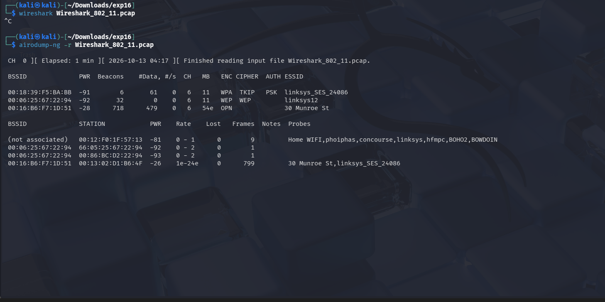

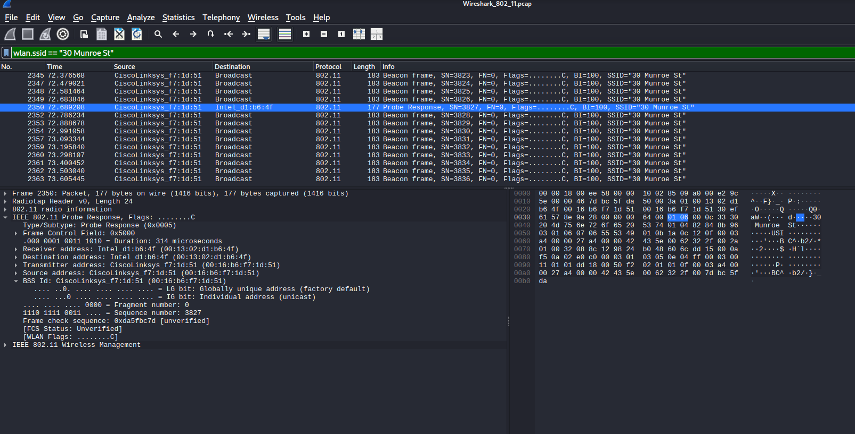

Results :

S. No. | Observation | Result
1 | Capture file analysed | Wireshark_802_11.pcap
2 | Capture type | IEEE 802.11 with Radiotap header
3 | Number of packets | 2,364
4 | Wireless network identified | 30 Munroe St
5 | BSSID verified in Wireshark | 00:16:b6:f7:10:51
6 | Operating channel | 6
7 | Beacon interval | 102.4 ms
8 | Network privacy indicator | Data confidentiality not required
9 | Client identified | Intel device, 00:13:02:d1:b6:4f
10 | Tools used | Wireshark, TShark, Airodump-ng

CONCLUSION :

The wireless network footprinting experiment was performed successfully using an offline IEEE 802.11 packet capture. Wireshark was used to examine beacon and probe-response frames and identify the SSID, BSSID, channel, beacon interval, and privacy capability. Client MAC-address information was also observed, and Airodump-ng was used to inspect the detected wireless networks and stations. The experiment demonstrated how wireless network details can be identified from captured frames without performing a live scan.

